 | INDUCED RADIOACTIVITY IN THE ATLAS EXPERIMENT – AN UPDATE  V. Hedberg - Univ. of Lund | 
Date: 2003-05-19 |  | RPC/2003/XXXVIII/137

INTRODUCTION
The project of calculating the induced radiation in the ATLAS experiment was presented in a note [1] and a talk [2] to the CERN Radiation Protection Committee in May of year 2002. This project is now finished and this report contains some additional results that were not available a year ago. All the calculations presented here have been calculated by a group of physicists at the Moscow Engineering Physics Institute (MEPhI) that has been contracted by ATLAS for this purpose. A web site [3] has been set-up with detailed information about all the ATLAS activation calculations and in this note only a small selections of the results will be presented. The conclusions in this note are those of the author and do not necessarily represent the opinions of the ATLAS collaboration.
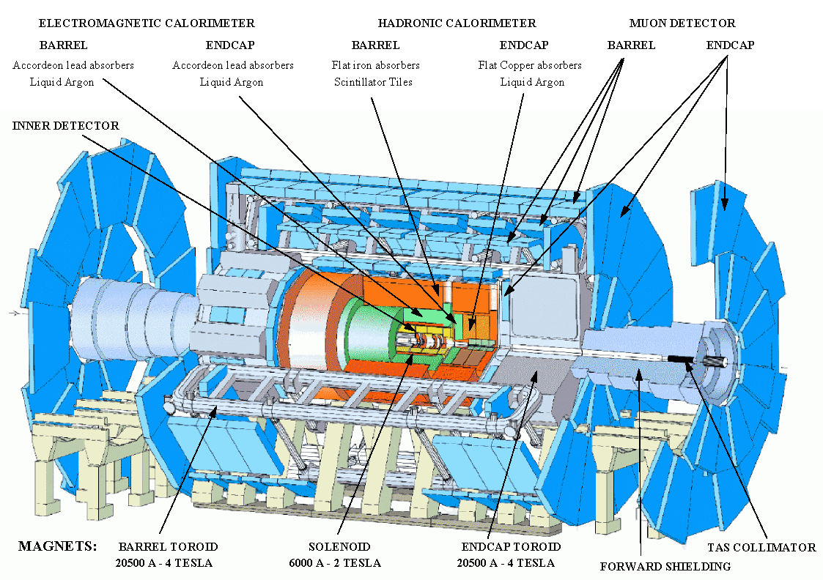

Figure 1: The ATLAS experiment.

METHODS AND ASSUMPTIONS
The induced radioactivity was calculated under the assumptions of 7x7 TeV collisions and a luminosity of 10³⁴ cm²/s giving a p-p interaction rate of 8 x 10⁸ s⁻¹ as predicted by the PHOJET program [4]. The secondary particle production due to interactions between the primary particles (simulated by PHOJET) and the material in the experiment was calculated [5] using the GCALOR program [6].

The activity from all possible processes resulting in radioactive nuclei was calculated using the standard activation formula [7,8]. The particle flux maps produced by the PHOJET and GCALOR programs were used as inputs in the calculations. The calculations were made separately for (n,γ) capture of low-energy thermal neutrons and high energy hadrons. In the latter case the lack of knowledge of the cross sections above 20 MeV for all possible types of interactions made it necessary to make the assumption that the cross section of all incident hadrons would be the same as that of protons [9]. The codes DOT-III [10] and MCNP [11] were used to calculate self-absorption and photon transport. Only gamma radiation was calculated. An LHC year was assumed to consist of 120 days of continuing running with a 245-day stop.

RESULTS OF THE CALCULATIONS
The induced radiation in many parts of the ATLAS experiment has been calculated and more than 600 radiation maps for different regions, running times and cooling off times are now available on the ATLAS activation web-pages. A large expected doserate from the beampipe has been reported in the previous presentation together with the two main access scenarios of ATLAS. Here will therefore be discussed two areas in ATLAS that had not been studied in detail at the time of the last report. One is the region of the TAS collimator (see Figure 1). This region is not easily accessible but it is expected to become one of the most radioactive parts of the entire LHC complex. The TAS collimator is a 1.8 m long copper cylinder with a 38 mm diameter hole for the beampipe. It is protecting the LHC magnets from the intense radiation coming from the interactions in the ATLAS experiment. The TAS lowers the amount of energy that is deposited in the Q1 quadrupole magnet and thus prevents it from quenching at high luminosity running.

Figure 2 show the expected induced radiation around the beampipe between the TAS collimator on the right side of the plot and the JT copper shielding (which is surrounding the beampipe inside the toroid magnet) on the left side of the plot. In this scenario it is assumed that the forward shielding (see Figure 1) has been removed as a first step to get access to the experiment. The beampipe is in this region surrounded by a support cone made of Aluminium and this cone prevents people to get direct access to the beampipe. The support cone act as a radiation shield and the typical contact doserate on the support cone is a few hundred μSv/h rather than the several mSv/h that is predicted for the beampipe in other parts of ATLAS.

The radiation in Figure 2 is what the experiment will have to deal with during the so-called Standard Access scenario. The only work that is needed around the beampipe during this access scenario is related to the removal of the forward shielding. During this work it can be necessary for people to work within one meter of the beampipe and thus in a radiation field approaching 100 μSv/h. In the Inner Detector Access scenario the beampipe will have to be removed. The flange at the toroid side will have to be undone manually and the expected contact doserate for this flange is about 2 mSv/h. On the TAS side the doserate is even higher but here one has foreseen to use a remotely controlled flange and people therefore do not have to work there. After the beampipe has been removed one is left with the radiation field depicted in Figure 3. There is a 1 m x 2 m region where the doserate exceeds 100 μSv/h due to the very radioactive TAS collimator. It is not necessary for people to have access to this region but it is anyway foreseen to mount a temporary lead plate in front of TAS in order to reduce the radiation from it.

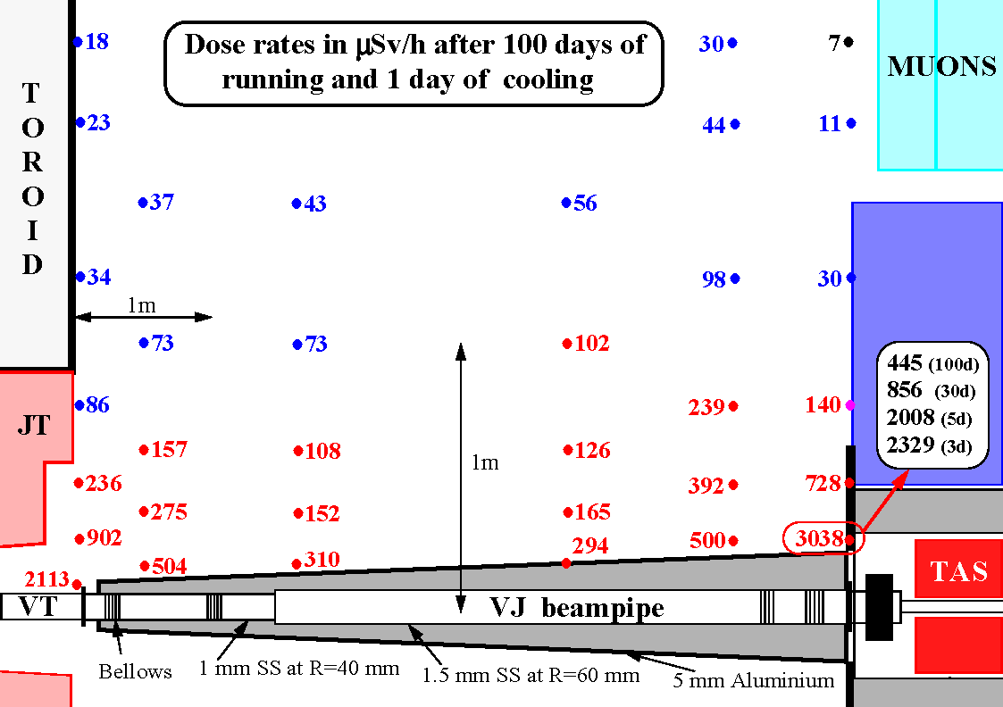

Figure 2: The expected doserate in μSv/h around the VJ beam pipe. The calculation includes radiation from the beampipe and its support cone, the JT toroid magnet copper shielding, the TX1S shielding (in blue) and the TAS copper collimator. The cooling off time is one day except for one point where doserates for several cooling off times are given.
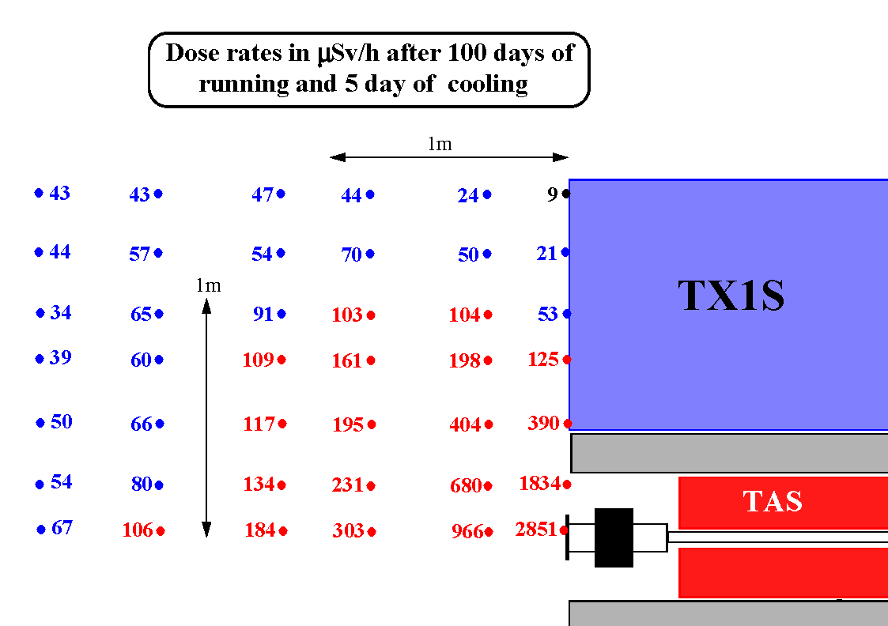

Figure 3: The expected doserate in μSv/h around the TAS collimator after the VJ beampipe has been removed. The calculation includes induced radiation from the remaining beampipe, the TAS collimator and the TX1S iron shielding.

Another region of ATLAS that has been studied in detail is the Inner Detector region. Due to the intense radiation that is expected from the beampipe, the Inner Detector can hardly be worked on at all during Standard Access. During the Inner Detector Access, the platform seen in Figure 4 will be installed.

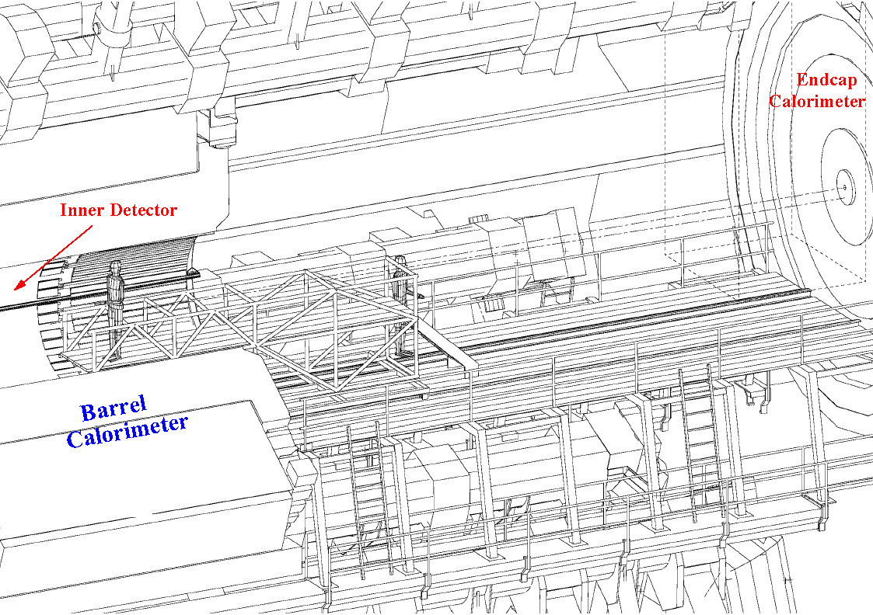

Figure 4: The platform that will be installed between the barrel and endcap calorimeters during Inner Detector access. This platform will make it possible to service the Inner Detector. The dashed lines in front of the Endcap calorimeter indicate the region to which the cavern crane has access and all heavy material will have to come down in this zone.

The platform itself and all other heavy material will have to come down in the zone indicated with dashed lines in Figure 4 since this is the only region to which the cavern crane has access. People will therefore have to work in front of the Endcap Calorimeter. The radiation field from this detector is shown in Figure 5. There is a 1 m x 0.5 m region around the hole for the beampipe where the radiation is expected to exceed 100 μSv/h. This region should be closed off with temporary shielding.

On the opposite side of the platform is the Inner Detector. Many different maintenance scenarios of the Inner Detector have been studied and here only one example, corresponding to the situation in Figure 4, will be given. In this case it is assumed that the Pixel Detector and the Inner Detector beampipe have been removed. It is furthermore assumed that one of the endcaps of the TRT and SCT detectors have been removed to give access to the barrel part of the Inner Detector. The predicted doserates in this maintenance scenario is given in Figure 6 and they vary between 20 and 40 μSv/h depending on location and cooling off times. Similar predicted doserates have been obtained for other maintenance scenarios involving the Inner Detector (with the exception for a couple of hotspots where the contact doserate reaches 100 μSv/h).

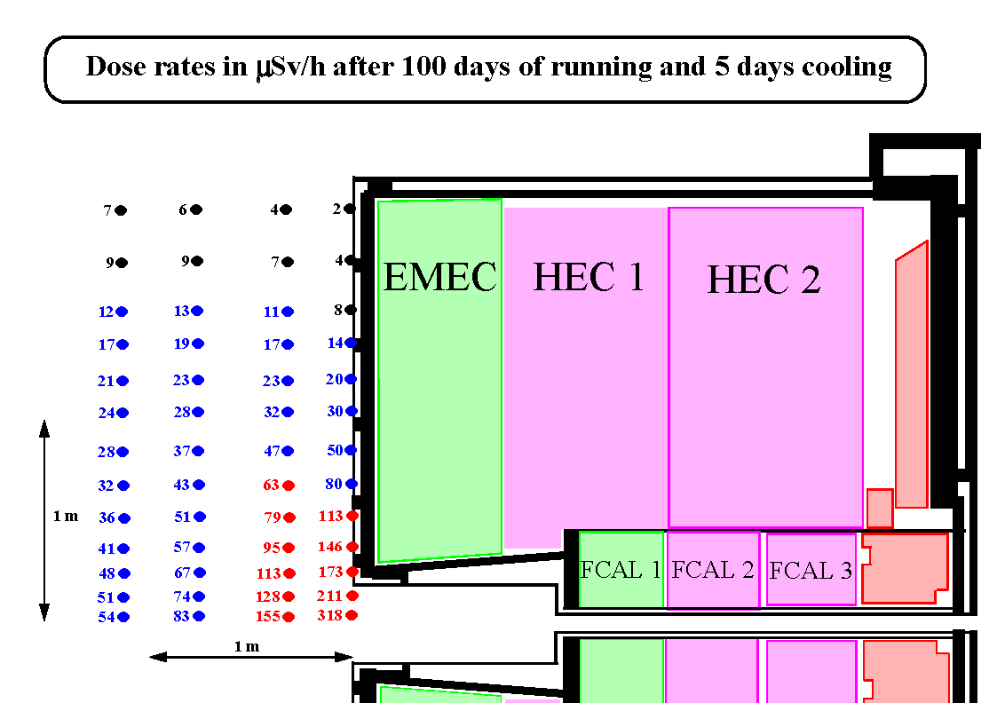

Figure 5: The expected doserate in μSv/h in front of the Endcap Calorimeter. The calculation was done for 100 days of continuous running and 5 days of cooling off.

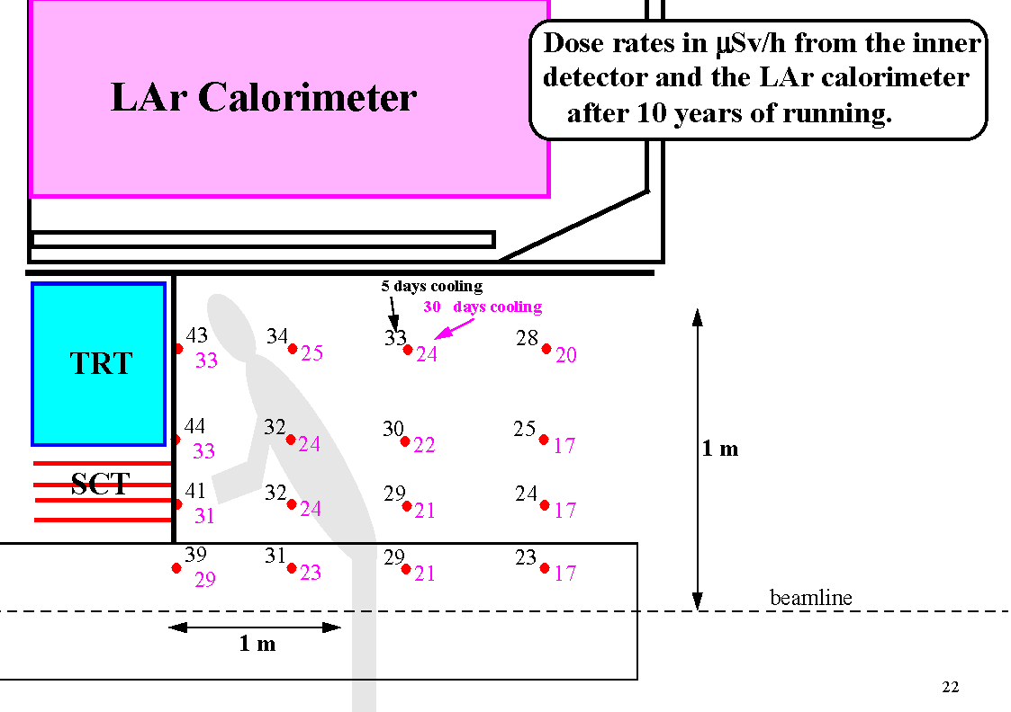

Figure 6: The expected dose-rate in μSv/h during access to the barrel part of the Inner Detector. The calculation was done for 10 years of running time and two different cooling off times.

CONCLUSIONS
Since the previous presentation to the CERN Radiation Protection Committee in May of year 2002 there has been progress made in ATLAS regarding the understanding of the details of the access and maintenance scenarios. Many more calculations have been done and only a few examples have been presented in this report. The main conclusions are:

- The beampipe will be the major source of induced radiation in ATLAS with contact doserates exceeding several mSv/h. During standard access, when the beampipe is not removed, the access to the area around the beampipe will therefore have to be very restricted.
- The procedure of removing the beampipe has to be optimised from a radiation protection point of view.
- In the Inner Detector Access scenario there are some hotspots in front of the TAS collimator and the Endcap Calorimeter where it is predicted that the doserate could exceed several hundreds of μSv/h. These hotspots can be shielded with temporary lead screens.
- The maintenance of the Inner Detector itself will not give the people involved doserates that exceed 30 μSv/h.

The project of calculating the induced radioactivity in ATLAS is now over but the work of designing a work environment that will expose the fewest possible number of people to the lowest possible doserate continues.

REFERENCES
[1] V. Hedberg, Induced radioactivity around the beampipe in the ATLAS experiment, RPC report RPC/2002/XXXVI/133
http://atlas.web.cern.ch/Atlas/TCOORD/Activities/CommonSys/Shielding/Activation/radiation_atlas.doc

[2] V. Hedberg, Induced radioactivity around the beampipe in the ATLAS experiment, transparencies http://cern.ch/vhedberg/atlas/transp/rpc_13_may_2002.pdf

[3] The ATLAS activation studies http://atlas.web.cern.ch/Atlas/TCOORD/Activities/CommonSys/Shielding/Activation/activation.html

[4] R. Engel and J. Ranft, Hadronic photon-photon interactions at high-energies,
Phys. Rev. D54(1996)4244

[5] by M. Shupe at the Univ. of Arizona.

[6] C. Zeitnitz, The GCALOR simulation package
http://www.physik.uni-mainz.de/zeitnitz/gcalor/gcalor.html

[7] V.A. Klimanov, E.I. Kulakova, M.N. Morev and V.K. Sakharov, Activation study of the ATLAS detector, ISTC Project #1800, April-June 2001, Moscow Engineering Physics Institute.
http://atlas.web.cern.ch/Atlas/TCOORD/Activities/CommonSys/Shielding/Activation/report_1_2_new.pdf

[8] V.A. Klimanov, E.I. Kulakova, M.N. Morev and V.K. Sakharov, Activation doserate in access scenarios to the area between the disk shield and the toroid, ISTC Project #1800, July-September 2001, Moscow Engineering Physics Institute.
http://atlas.web.cern.ch/Atlas/TCOORD/Activities/CommonSys/Shielding/Activation/text_tab_1_4.pdf

[9] V.G. Semenov and N.M. Sobolevsky, Approximation of Radionuclide Production Cross section in Proton Induced Nuclear Reactions. Report on the ISTC project #187, Moscow, 1998

[10] F. Mynat et al., The DOT-III Two-Dimensional Discrete Ordinates Transport Code, ORNL-TM-4280, Oak Ridge, 1973.

[11] J.F. Briesmeister, MCNP - A general Monte Carlo N-Particle Transport Code, Version 4A, Los Alamos National Laboratory Report, LA-12625, 1995.

